Project Design Phase-II Technology Stack (Architecture & Stack)

Date | 1 Feb 2026
Team ID | LTVIP2026TMIDS24929
Project Name | Empowering India : Analysing the evolution of union budget allocations for sustainable growth
Marks | 2 Marks

Technical Architecture:
The Deliverable shall include the architectural diagram as below and the information as per the table1 & table2

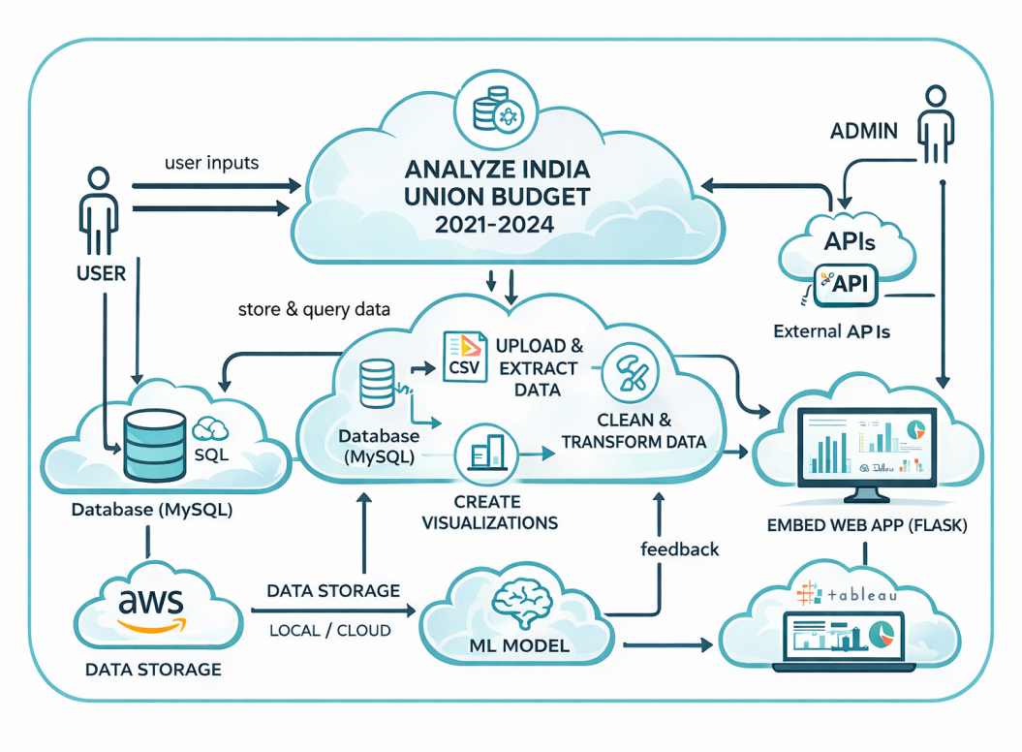
Guidelines:
Include all the processes (As an application logic / Technology Block)
Provide infrastructural demarcation (Local / Cloud) Indicate external interfaces (third party API’s etc.) Indicate Data Storage components / services Indicate interface to machine learning models (if applicable)

Table-1: Components & Technologies:

S.No | Component | Description | Technology
1. | User Interface | Interactive dashboards and story to visualize Union Budget insights | Tableau Public, HTML, CSS (for embedding)
2. | Data Preparation Logic | Cleaning, filtering, transforming Union Budget dataset before analysis | Python (Pandas, NumPy) / Tableau Data Prep
3. | Data Analysis Logic | KPI calculations such as total budget, growth %, revenue vs capital analysis | Tableau Calculated Fields, SQL Queries
4. | Data Source | Government Union Budget dataset (2021–2024) | CSV Files (Kaggle Dataset)
5. | Database | Structured storage of cleaned Union Budget data | MySQL
6. | Cloud Storage (optional) | Backup and hosting of dashboards and reports | Tableau Public Cloud
7. | File Storage | Local storage for dataset, project files, documentation | Local Filesystem
8. | External API(Optional) | Government open data portals for extended economic data (if integrated) | data.gov.in API (Optional)
9. | Machine Learning Interface (Optional) | Budget trend prediction or growth forecasting | Python (Scikit-learn – Optional)
10. | Infrastructure | Development and deployment environment | Local System + Tableau Public Cloud + Flask Web Server

Table-2: Application Characteristics:

S.No | Characteristics | Description | Technology
1. | Open-Source Frameworks | Tools used for data cleaning, analysis, and visualization | Python (Pandas, NumPy), MySQL, Tableau Public, Flask
2. | Security Implementations | Secure database credentials, limited public exposure via Tableau Public | MySQL Authentication, Environment Variables
3. | Scalable Architecture | Can scale by adding more fiscal years or integrating economic indicators | MySQL (Scalable DB), Tableau Public Cloud
4. | Availability | Accessible online via Tableau Public and Flask Web App | Tableau Public Cloud, Localhost Deployment
5. | Performance Optimization | Optimized SQL queries, filtered data extracts, minimal heavy joins | MySQL Indexing, Tableau Extract Mode

